**(Title page)**

**The title of the article**

**(Times New Roman, 12, Bold, Centered, Line spacing: single)**

Author 1 – name and scientific title

Organization:

Mailing address:

E-mail:

Year of birth:

Author 2 – name and scientific title

Organization:

Mailing address:

E-mail:

Year of birth:

Author 3 – name and scientific title

Organization:

Mailing address:

E-mail:

Year of birth:

Name of the author acting as contact person:

Acknowledgements or identification of the research sponsor.

*Only the title page is allowed to contain information about the authors. This contributes to the anonymous evaluation of the manuscript.*

**The title of the article in English**

**(Times New Roman, 12, Bold, Centered, Line spacing: single)**

Empty row

Empty row

**Abstract in English**

Times New Roman, 12, Justified, Line spacing: single, 150 words.

Empty row

**Keywords (English):** maximum 5.

Empty row

**JEL code:** XXX.

Empty row

**The title of the article**

**(Times New Roman, 12, Bold, Centered, Line spacing: single)**

Empty row

Empty row

**Abstract in Hungarian**

Times New Roman, 12, Justified, Line spacing: single, 150 words.

Empty row

**Keywords:** maximum 5.

Empty row

**JEL code:** XXX.

Empty row

Empty row

**Introduction**

Empty row

Please submit the article in digital form, as a Word file. Use normal Times New Roman, font size 12, single line spacing and justified alignment. Page layout should be A4 with 2.5 cm margins (left, right, top, and bottom). Article size should be 6,000–10,000 words. Do not apply page numbering.

Differentiate the titles and subtitles in the article from paragraph text by bold formatting. Use no more than two heading levels. Insert an empty row before and after section headings. Do not apply heading numbering.

(Example:

Empty row

**Chapter title**

Empty row

Text

Empty row

***Section title***

Text

*Section title*

Text

*Section title*

Text

Empty row

***Section title***

etc.)

Mark paragraph breaks with Enter (not Tab, empty row or space characters).

Empty row

**Literature review and theoretical/conceptual framework**

Empty row

In-text citations shall be referenced in parentheses as follows: the author's surname and year of publication, and, when appropriate, the page number as well. Example: (Gyerőffy 1997. 55). It is recommended to use Word's Reference function.

Use footnotes only for explanations. It is recommended to use the automated footnote numbering with 1, 2, 3...

Use italic formatting to highlight words or ideas in the text, do not use bold, underline, or all caps formatting, or spaces between the letters of the highlighted word. Use quotation marks exclusively for quotations. Use highlighting only where it is indeed necessary. Apply the highlighting to the whole word, including suffixes.

Do not use space character between a word and a subsequent punctuation mark (period, comma, semicolon, colon, exclamation mark, question mark), only after the punctuation marks.

In numbers, do not use the letter O instead of the number 0 (zero). In normal text, numbers larger than 10,000 shall be divided in groups of three digits, using space characters rather than periods as thousand separators, e.g. 18 325 655. No thousand separator shall be used for numbers up to 9999. If four-digit numbers are included in table columns along with five-digit or larger numbers, thousand separators shall also be used in numbers between 1000 and 9999. Note: place values shall be aligned in the columns, i.e. ones should be under ones, tens under tens, etc.

Tables are to be in Word format (photocopies, pictures, photos, web copies are not accepted).

Tables shall be referenced in the text by the table number (not as "the above table" or "the table below"). Each table shall have a title above the table with the source identified below the table (in the format shown in the example). Insert an empty row before and after the table.

Do not apply colours in the table and do not use Autoformat, as these cause difficulties to the editor. It is recommended to use simple formats similar to the example. Please also attach the tables as Excel files. Please consider the size of the publication (130/190 mm printable area) when creating tables.

Example for table formatting:

Empty row

**Table 1: Title (Times New Roman 10, Bold, Centered)**

|  |  |
| --- | --- |
| **XXXXXX** | **YYYY** |
| ZZZZZ |  |
|  |  |
|  |  |

Source: Times New Roman 10, Alignment: right

Empty row

Figures shall always have a title and source identification below the figure (in the format presented in the example). Insert an empty row before and after the figure.

In case of charts created in Excel, please attach the original Excel file. In case of charts or any other figures submitted in image format shall be published in black and white, when creating the image, please ensure that the image can be interpreted in black and white as well. Enclose to the article the original image in electronic format (*.jpg, *.tif, *.cdr, illetve *.psd) in the best possible quality (recommended formats: *.jpg, *.tif).

Example for the appearance of figures:

Empty row

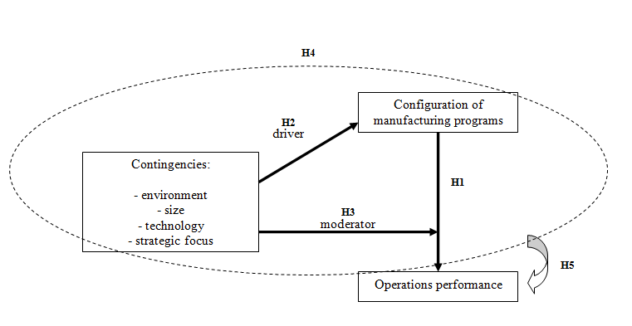

Source: Times New Roman 10, Alignment: right

Empty row

**Figure 1: Title (Times New Roman 10, Bold, Centered)**

Empty row

Example for lists:

* xxxxxx
* xxxxxx

Mathematical formulas shall be numbered on the right side:



Variables shall be explained below the formula.

Empty row

**Bibliography**

Use the author-date system for formatting the reference list. After the title, include the volume and edition number, if applicable:

Zalai, E. 2012. *Matematikai közgazdaságtan II. Többszektoros modellek és makrogazdasági elemzések*. Budapest: Akadémiai Kiadó.

If a book has two or more authors, use em dash (–) between the names:

Pepall, L.–Richards, D. J.–Norman, G. 2008. *Piacelmélet – Modern megközelítés gyakorlati alkalmazásokkal.* Budapest: HVG-ORAC Lap- és Könyvkiadó Kft.

An article published in an anthology is marked with "In":

Alvarez, K. 2001. A barnamezők és rozsdaövezetek gazdasági újjáélesztési programja az Egyesült Államokban. In: Éri, V. (ed.) *Terjeszkedés vagy ésszerű városfejlődés?* Budapest: Környezettudományi Központ, 75–79.

Article published in a magazine:

Rózsa, G. 2010. A fogyasztási és jövedelmi viszonyok regionális különbségeinek alakulása 1994 és 2007 között. *Statisztikai Szemle* 88(4), 371–395.

Books:

Fukuyama, F. 2000. *A nagy szétbomlás*. Budapest: Európa Könyvkiadó.

PhD thesis:

Baranyi, Á. 2001. *Környezetvédelmi stratégiatípusok a magyarországi feldolgozóipari vállalatok körében*. PhD Thesis. Budapest: BKÁE.

Document accessed on a website:

Hajdú, I. 2008. *Acélváros: társadalom és építészet kölcsönhatásában*. <http://www.atjarokhe.hu/wp-content/uploads/2009/12/hajdu-ildiko-acelvaros-tarsadalom-es-epiteszet-kolcsonhatasaban.pdf>, accessed: 2012.04.18.

**Appendix: Title (Times New Roman 10, Bold, Centered)**

**Empty row**

#### XXXXX (Times New Roman, 10, Justified)